TITANIUM SNAP MANUAL

Underwater Acoustic Recorder

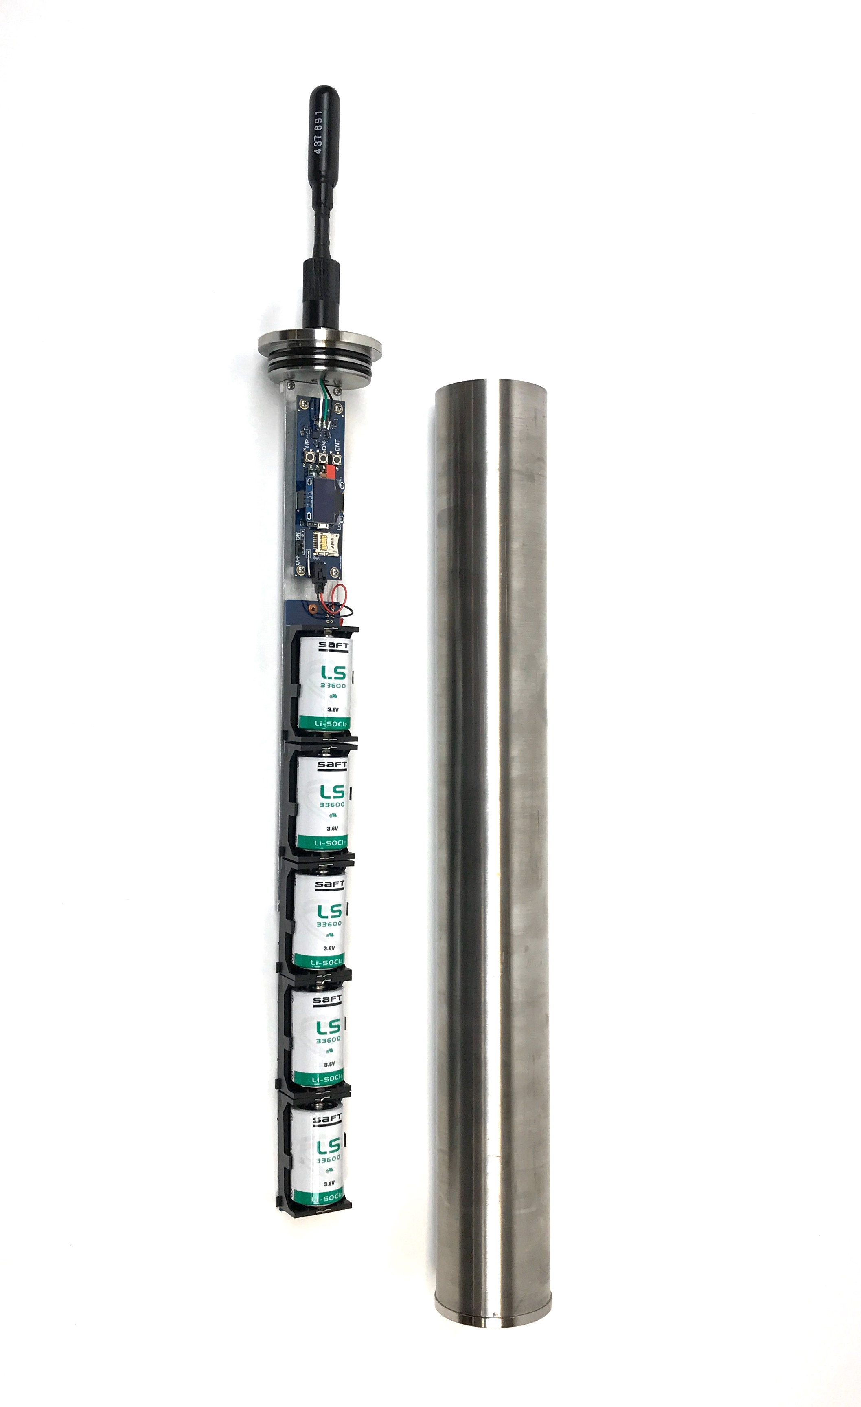

Manual v4.0
Updated 13 January 2024

www.loggerhead.com

Overview

Hardware

Titanium Snap is a datalogger designed for collecting large amounts of underwater acoustic recordings. Setup is designed to run through a simple button interface with a display. No PC is needed to setup and deploy the Snap.

Software
Snap stores data directly as audio wav files.
Any audio analysis software (Adobe Audition, Cornell Raven, MATLAB, R, Python) will work with these files.

For noise analysis, the open source Manta software is designed to run with audio files collected by the Snap.
https://bitbucket.org/CLO-BRP/manta-wiki/wiki/Home

Setting up Snap for Deployment

Step 1. Prepare microSD card. The microSD card should be formatted as exFAT. This is how new large cards are formatted at the factory. It is a good idea to periodically reformat the card between deployments.

Step 2. O-rings. Clean and grease o-rings with silicone grease and insert into the groove on the ring. The o-rings (-228) are McMaster part number: https://www.mcmaster.com/9452K66/

Step 3. Turn on power switch.
The Titanium Snap uses 5 primary lithium batteries that are 3.7V each. We recommend SAFT LS20. Always use all 5 slots, even for a short deployment.

The microSD cards will be scanned for free memory. There MUST be a card in the Snap.

Use buttons to change settings
UP/DN: Used to move through menu settings and make changes.
Enter: Used to change values.

Display Setting | Description
Start | Press Enter to Start
Record | Record duration in seconds
Sleep | Sleep duration in seconds. This is the time from the END of one recording to the START of the next recording.  Continuous Recording: Sleep = 0 seconds
Rate | Sample Rate
Gain | Gain of the audio codec. The gain setting ranges from 0 to 15 and the corresponding dB of gain will be shown in the display
Time | It is highly recommended to use UTC time.
Year: | Year
Month: | Month
Day: | Day of month
Hour: | Hour (24 hour time)
Minute: | Minute
Second: | Second
Battery | This corresponds to the number of batteries in parallel. Only used to calculate power requirements.
Delay | The number of days to delay starting recording from the time the Snap is started. The LED on the board will blink briefly approximately every 20 s after starting while in sleep mode.

Step 5. Start Recording. Press Enter when the display shows START to start recording. If this is not done, the recorder will automatically start after 10 minutes.

Step 6. Close lid. Snap the lids into place. The water pressure will hold the lid in place underwater. If you are deploying where the water is warm, it is best to open the Snap and close the lid outside just prior to deployment. Since cold air expands when heated, it is best not to close them up inside an air-conditioned room and then deploy in water that is warmer than the air-conditioned room.
If your Titanium Snap is equipped with a vent plug in the bottom lid, release pressure on this plug after putting on the top lid, and then reseal. This will remove the positive pressure inside the housing and help the endcaps stay on while on deck.

Step 7. Deploy. The Snap can be attached to a bottom mount (e.g. cinder block) or subsurface line using hose clamps or large tie wraps.

Retrieval
Upon retrieval, open the top lid by pushing up on opposite sides of the lip, and pull out the Snap board.
If your Titanium Snap has a bottom vent plug, you can vent the plug to make removal of the top lid easier.

If a recording is still happening (red hydrophone LED on and green LED on board flashing), hold down the UP + DN buttons at the same time. This will properly close the file before stopping recording. Then switch off the board and remove the microSD card.

HTI Hydrophone and Recording Gain

The Snap uses a hydrophone manufactured by High-Tech Inc. The sensitivity of the hydrophone will be on a specification sheet included with the shipment (typically -170 dBV/uPa or -180 dBV/uPa).

The hydrophone may have a red LED in the end to indicate when it is getting power. This will only be turned on during startup and recording. The hydrophone red LED will be off when sleeping.

The A/D converter gain can be changed through the setup.txt file. The default is setting 4. The setting can be changed with SG command in setup.txt. The actual setting that was used is stored to the file name.

Setting | Clip Level (peak-peak) | Clip Level (peak) | Gain (dB)
0 | 3.12 | 1.56 | -3.9
1 | 2.63 | 1.315 | -2.4
2 | 2.22 | 1.11 | -0.9
3 | 1.87 | 0.935 | 0.6
4 | 1.58 | 0.79 | 2.0
5 | 1.33 | 0.665 | 3.5
6 | 1.11 | 0.555 | 5.1
7 | 0.94 | 0.47 | 6.6
8 | 0.79 | 0.395 | 8.1
9 | 0.67 | 0.335 | 9.5
10 | 0.56 | 0.28 | 11.1
11 | 0.48 | 0.24 | 12.4
12 | 0.4 | 0.2 | 14.0
13 | 0.34 | 0.17 | 15.4
14 | 0.29 | 0.145 | 16.8
15 | 0.24 | 0.12 | 18.4

